Marina Dock Age & The Docks Expo 2018
Kerry Gonzalez, CEO
AMG Insurance International, LLC
Journey to ‘Best in Class’ – Marine Facilities & Contractors Best Practices for Risk Management, Safety & Storm Planning
RISK MANAGEMENT AND SAFETY: Characteristics of ‘BEST in CLASS’:

Standard of Care with:  *Care/Custody/Control of Property of Others (ie. Boats)  *Preservation, maintenance and improvement plans for owned and leased property | Contracts required and kept current related to:  *Boats/yachts/charters  *Subcontractors and other vendors  (with additional insured status and/or a waiver of subrogation required and indemnification/hold harmless language) | Maintenance Plan/Program:  *Regular equipment maintenance and storage including lockout/tagout procedures and checklists kept on file  *Regular building and dock maintenance program and/or third-party contracts for maintenance
Formalized Safety Policies and employee training in writing:  *Lifts and Specific Equipment  *Fueling  *Boarding customer vessels  *Good Samaritan Acts  *Repair work  *Monthly Safety meetings | Security of the Premises:  *Fire Protection – EVERY dock, within view of EVERY part of the marina – to include extinguishers, life rings, ladders, spill kits.  *Lighting, Fencing, Other Restricted Access  *Cameras and Alarms  *Appropriate signage  *After Hours Emergency Personnel or Contact | Disaster Preparedness:  *Checklists integrating delegation and accountability  *Drills and employee awareness of expectations  *Components of the property including consideration of the ‘lifespan’ of these components not limited to: floating vs. fixed docks, JOINTS (including the regular maintenance of them), seawalls, breakwaters and pylons with extensions and blocks ready to install.
Management/Employee Experience and Training | Labelling:  *Hazard areas/MSDS labels  *Warning signs  *Current certification of fire and fueling equipment | The Basics:  *Housekeeping  *Insurance History

Why do you want to be ‘Best in Class’?

Peace of Mind

Ownership Pride

Preservation of Investment – yours and your lenders

Better Insurance Market and Coverage Options

Better Insurance Rates

Better Employee Moral, Safety and (often) Tenure

‘AT CAPACITY’ facility – a ‘Best in Class’ risk approach promotes trust with the general public, a sense of security and comfort and increased foot traffic.

The MARINE insurance contract:

Based on a ‘partnership’ on the following:

- Risk transfer
- Risk avoidance
- Risk control/risk management and risk assumption

Sometimes based on ‘conditions and subjectivities’:
Examples:

- Compliance with regulatory requirements including OSHA, U.S. Coast Guard, EPA, DNR, Fire and Building Codes, NFPA codes and standards (remember, though there are incidental places where there may be insurance coverage for fines/penalties, insurance is almost never intended to pay for fines/penalties)

- Maintenance and tracking of Certificates of Insurance from Third Parties

- Executed (ongoing and kept current) contracts with third parties that have indemnification/hold harmless agreements that are fair and/or in your favor to protect YOUR investment and the investment the insurance company is making in YOUR risk.

- Maintenance and security expectations

- Property appraisals to confirm you are ‘insuring to value’

The MARINE insurance contract (continued):

Often based on a ‘warranted application’ that if/when falsified, can lead to the following:

- Cancellation of insurance
- Voiding coverage
- Reduction of coverage
- Additional premium
- Legal implications, even criminal in some States.

All statements (or omissions of statements that should have been made) should be based on facts (as soon and as often as they become known).

It is imperative that you have an ongoing dialog with your insurance agent/company as misrepresentation can be intentional OR unintentional.

Expectation of ‘material representation of fact’:

- You represent to the agent/insurance company that:

  - Your operations (including every revenue stream) have all been disclosed
  - Your revenue and payroll amounts for every source/type have been estimated honestly.
  - Your contracts and relationships with third parties have all been disclosed
  - Your property details have all been disclosed
  - You have insured your property to value OR chosen to self-insure

CERTIFICATES OF INSURANCE FROM THIRD PARTIES: BOAT OWNER (SAMPLE):
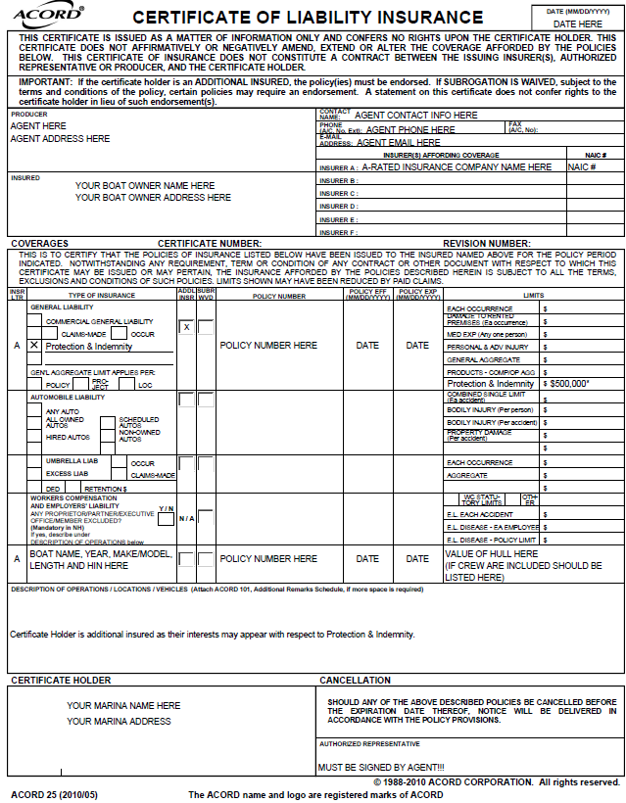
CERTIFICATES OF INSURANCE FROM THIRD PARTIES: SUBCONTRACTOR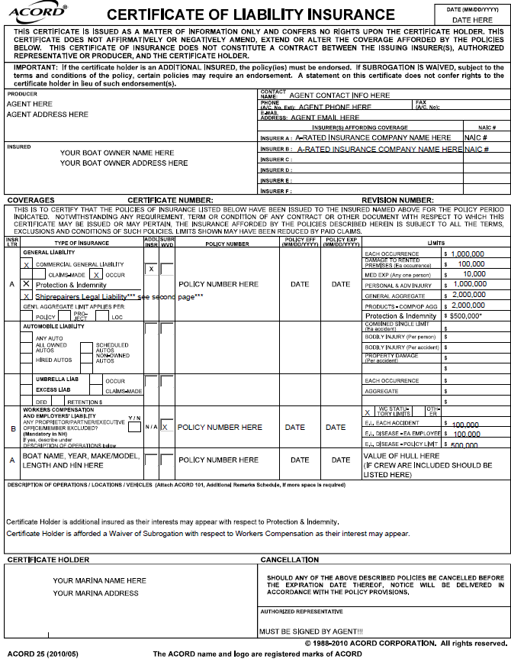
CERTIFICATES OF INSURANCE FROM THIRD PARTIES: ADDENDUM

In section one (under General Liability) or in the comments section of the Certificate of Insurance (COI) the contractor or vendor provides to your facility, coverage should be included for the following types of insurance:

This is indeed a choice every marine facility is faced with – one of three things will happen in the event of a claim:

- third parties insure their own exposures listing you as additional insured as your interests may appear

- your insurance picks up their exposures AND you pay a premium for it (either during the policy or at audit) and you may end up in disputes related to moonlighting.

OR

- neither transpires due to exclusions and you end up footing the bill for bodily injury, property damage or professional liability for their work on your premises.
CHALLENGE
QUESTION: What if third parties are working DURING a claim to repair damage?

ANSWER: Your facility should have the same expectation for all contractors regardless of the scope or reason for the work. You have the same three choices as noted above related to risk transfer, risk avoidance or assuming risk of third parties.

CERTIFICATES OF INSURANCE FROM THIRD PARTIES: OTHER SCENARIOS:
(In addition to the coverage on the sample Certificate provided)

Boat Dealer/Yacht Broker or Parts/Engine Supplier:

- Should include Yacht Brokers Legal Liability with a limit for ‘any one vessel’ for the maximum value of any vessel they might sell, Marine Operators Legal Liability and Marine General Liability.

Artisan Contractors:

(including General repair, electrical work, detailing/cleaning, welders, carpentry, canvas, sails/rigging, engine work, fiberglass, painting, winterization or shrink wrapping):
- Should include Ship Repairers Legal Liability (SRLL) with a limit of $1,000,000

Rental Fleets:

- Should include Protection & Indemnity of $1,000,000 plus Medical Payments of $10,000 with a schedule of all vessels that includes the year, make, length, HIN, engine year, make and serial number.

Boats/Yachts:

- Should have Protection & Indemnity of EITHER $500,000 or the limit you feel would repair or replace and average boat or dock in your marina.
- Includes Jet skis/tenders
- If a liveaboard, COI should state such (for the purpose of insurance, liveaboard means they have no other property lease or mortgage and is not based on amount of time spent on the vessel)
- Should list any captain/crew that are included
CERTIFICATES OF INSURANCE FROM THIRD PARTIES: OTHER SCENARIOS (Cont’d):(In addition to the coverage on the sample Certificate provided)

Charter Vessels:

- 6-Pack Charters $500,000 Protection & Indemnity or the limit you feel would repair or replace and average boat or dock in your marina.
- Inspected Vessel Charters should include the number of passengers the vessel is insured/inspected for
- Names of Captain/Crew should be included.

Liquor Vendors (including charter boats that may provide alcohol to customers):

- Should also have a minimum of $1,000,000 Liquor Liability limits that includes coverage for Assault and Battery

Other Licensed Professionals:

(such as surveyors, security, architects, engineers, sailing or boating instruction)
- Should have $1,000,000 Professional Liability/Errors & Omissions coverage
- Security should have coverage included for Assault & Battery

Food Trucks or Shuttles:

- Should also have $1,000,000 Combined Single Limits with a schedule of any auto/truck used on your premises

General Contractors (renovations, additions, demolition, new construction):

- Should include Builders Risk to insure the total hard and soft costs of construction
Disclaimer: The above is intended to represent common examples, not all scenarios. Please consult with your insurance agent on specific situations!
STORM PLANNING: Characteristics of ‘BEST in CLASS’:

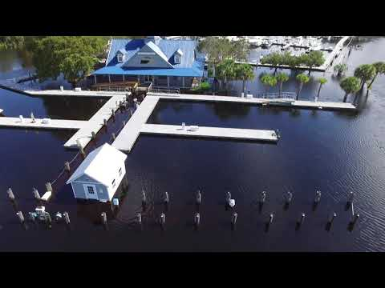

What if I ‘DO NOTHING’?

https://wpde.com/news/local/waccamaw-river-floods-murrells-inlet-restaurant

Storm Planning – No longer just for boats/yachts!

Prior to Hurricane Harvey or Irma, if a Florida Yacht (not boat) owner needed insurance, they needed to complete a ‘storm plan’ for insurance companies. This is an agreement between the yacht owner and the insurance company that they would be with their vessel before and during a Named Storm or would delegate care of their vessel to a third party who was listed on the storm plan with contact information. The plan usually included a ‘checklist’ of the due diligence the yacht owner would be responsible for including but not limited to securing of loose items, the number, type, thickness and length of the extra dock lines that would be used, the number of extra fenders that would be placed out, what would be done with sailboats in particular, including possibly unstopping of masts. If a vessel would not be in a marina, they were required to provide details on where and how they would be anchored, secured or blocked off if they would be on the hard. Since Irma, these ‘formal storm plans’ are being required for ALL boats and vessels not just in Florida but in the south in general.

Formal storm planning won’t just be for vessels in the future!

The Marine Facility:

Insurance companies have not historically required that marine facilities and contractors have a formalized storm plan. Employee training and checklists used while preparing for a storm can eliminate confusion and set priorities even before the storm is named. Many marina facilities were hit hard during Irma; some that were utterly wiped out had no formal plans to prepare for a storm and no checklist for employees or regular maintenance that could actually have kept them in business. Some marine facilities were completely wiped out.

Is your due diligence formalized and your staff prepared to set the bar with storm preparedness?

Can a story be told about what you have done to mitigate losses and minimize damage in advance?

Before the storm, are your expectations set with your staff and vessel owners?

Do you have a backup or paper copy of your customer list, their emergency contacts, their contracts and their insurance?

Do you have an emergency contact list ready for all authorities and contractors you may need after the storm?

Is it clear what your standards are with respect to handling of fuel and equipment?

What about regular maintenance of your docks, lifts and other things that could take flight during a storm? Do you have a regular maintenance schedule?

What training should be required of the $10/hour dockhand?

Can financial safety and training incentives for employees have a greater financial reward and return for you?

TYPICAL EXCLUSIONS:

- “Underwriting intent” and the grey areas of the policy

- History of the ‘ALL Perils’ policy to a trend of purchasing the least impact of exclusions such as:
  - FLOOD
  - WIND
  - Business Income (must apply to every policy/part of your property where income might be lost and must be tied to every ‘peril/cause of loss’ policy)
  - Sudden and Accidental Pollution
  - Terrorism

TYPICAL LIMITATIONS:

- Items that may need to be scheduled:
  - Revenue types (Liability class codes)
  - Buildings including storage pods, shelters, lean-to’s
  - Equipment exceeding a specific value per item (can vary slightly by company)
  - Lighting and signage
  - Workboats
  - Rescue/tow boats

- High deductibles with respect to:
  - Flood
  - Wind
  - Earthquake
  - Docks

- Duties under the policy
  - to avoid loss of life, injury
  - to mitigate loss, protect or move property
  - to promptly report claims

- Coinsurance penalties/implications for not ‘insuring to value’

- Business Income – Actual Loss Sustained vs. Coinsurance
  - Business Income Worksheet to determine appropriate limit
  - INCLUDE or EXCLUDE ‘ordinary’ payroll
  - Include Extra Expense (expenses incurred during the claim/repair/replacement that you would not have otherwise had without the damage)

WORKERS COMPENSATION, MEL, USL&H

(Marine Facilities AND Contractors)

Warning: Failure to comply with either Workers Compensation, United States Longshore & Harborworkers (USL&H) or MEL/Jones Act can lead to fines of up to $10,000 or more in some cases, immediate assigned premiums that could be several times your initial premium, implications of ‘misdemeanor’ and even possible closing of your business or jail time. This is a very brief overview; if you have concerns, you should review with your agent immediately!

Workers Compensation

STATE Act(s) – covers employees who are not working on/around navigable waters where maritime commerce would occur.

Each State mandates coverage after a certain number of employees; in some States (like Florida), it includes the owners, subcontractors and part time employees in that count.

Owners have the option of being included or excluded from coverage and payroll caps are set for each State each year for owners, officers and executives; however, this must be identified at the beginning of the policy year.

Jones Act (also known as the Merchant Marine Act of 1920):
Federal Act that extends employers liability to cover seamen (captain/crew) for personal injury on vessels that are owned; however, Maritime Employers Liability (MEL) provides coverage for employees that work on vessels owned by third parties.

United States Longshore & Harborworkers (USL&H)

Federal Act for employees who have duties that are primarily land based where there is a connection to maritime commerce who are working near/on navigable waters or aboard vessels. This includes work on adjoining piers, wharves, docks or while building, repairing or dismantling a vessel (if over 65’).

This would include but not be limited to dock hands, ship repairers, shipbuilders, pile drivers, dock builders, forklift operators and other such employees.

This does not apply to employees with 100% work in the office (ie. a clerical person in the office who does not ever leave the office for work on the dock).

Employees who rent recreational boats are exempt from USL&H and would only need Workers Compensation.

The Marine Contractor:

If you are a contractor, is the right insurance in place for you to take advantage of work that results from a storm?

If marine facilities follow these guidelines, the subcontractors they use must be insured and insured correctly. Are you ready?

If you are a new contractor, you may need a functional business resume to walk underwriters through your prior experience to make it more palatable to insure your risk. The narrative your agent gives underwriters about your experience tell underwriters what they need to know to factor in well-deserved discounts with your rates.

Are you a thought leader? Do you already have safety awareness? Superior training and supervision of employees that can prove to insurance companies that you are the ‘best in class for your business type’?

Do you understand both legal and possible contractual requirements for Workers Compensation, Longshoreman’s and/or Jones Act insurance?

RISK TRANSFER for the Marine Contractor:

What is your true cost of subcontracting and how can you minimize subcontracting risks and costs? Contractual insurance elements: the difference between assuming risk yourself, through your insurance or transferring your ‘risk’ to a third party. Same concepts apply to you as the ones we shared for marine facilities!

Your ‘NARRATIVE’:

The ‘narrative’ about your ‘risk culture’ will determine whether you make it through the next storm, the next employee turnover or the next allegation.

Are you ready for anything?

Is your insurance program structured for what you are not ready for?

Are you aware of the coverage you are NOT purchasing (aka ‘exclusions’)?

With the shrinking insurance marketplace, you need unparalleled peace of mind that you are Best in Class or are at least on your way there!

