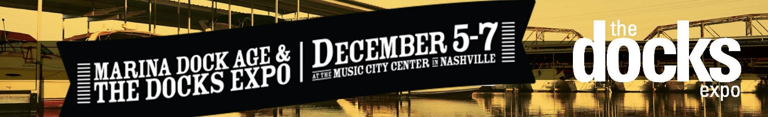

- How do I register for the event?
Online registration is now open! Please click HERE to register. If you have any questions regarding your registration, please contact Docks Expo Registration Services at registration@wjinc.net or 314-241-4310.
Please remember to wear your name badge as it will be required for admittance to the exhibit hall floor, education sessions, and refreshment breaks. Best of all, it serves as an introduction to others attending and exhibiting at The Docks Expo!

If your family has accompanied you to Nashville, please click here for dining and entertainment maps. Note that for safety reasons, children under the age of 16 are not permitted on the exhibit hall floor at any time.

- What is the tradeshow facility’s address?
Music City Centre
201 Fifth Avenue South
Nashville, TN 37203

Please click HERE for directions.

- The 2017 Schedule at a Glance can be found here.

- How do I make my hotel reservation?
Please use the link on the Hotel & Travel tab on our Docks Expo website. Book through this site to take advantage of Dock Expo’s special group rates at the Hilton Nashville Downtown.

- I will be driving to Music City Centre. Where should I park?
There are a several parking options surrounding the facility. Please click HERE for details regarding location, rates, and handicap accessible parking.

- How do I download The Docks Expo mobile event app?
To download The Docks Expo mobile app, open the event landing page at http://guidebook.com/g/docksexpo on your mobile device’s web browser. You will see a link to download the app in the app store. Follow the prompts to download the app.

- Where can I find the application form for the Marina of the Year awards?
Details and application forms can be found on the Marina Dock Age website. Applications are due by October 2, 2017.

- Please tell me more about the education opportunities available during The Docks Expo.
Marina Dock Age magazine and the University of Wisconsin-Madison’s Engineering Department are joining forces to provide incredibly valuable education at a fraction of the cost. The University’s nationally recognized Docks and Marinas course will now be included in your registration to the show. No separate registration will be required! Please check the 2017 Schedule for all sessions being offered.

- Click HERE for additional information on Nashville.

For tradeshow information, please contact:
Jenn DeLuca, Tradeshow Manager
jenn@wjinc.net or 314-296-1716

